**Data Engineering Assignment – 23**

**AZURE DEVOPS:**

Azure devops is the union of people, process and products to enable continuous delivery of value to your end users.

Let’s see how to use azure devops.

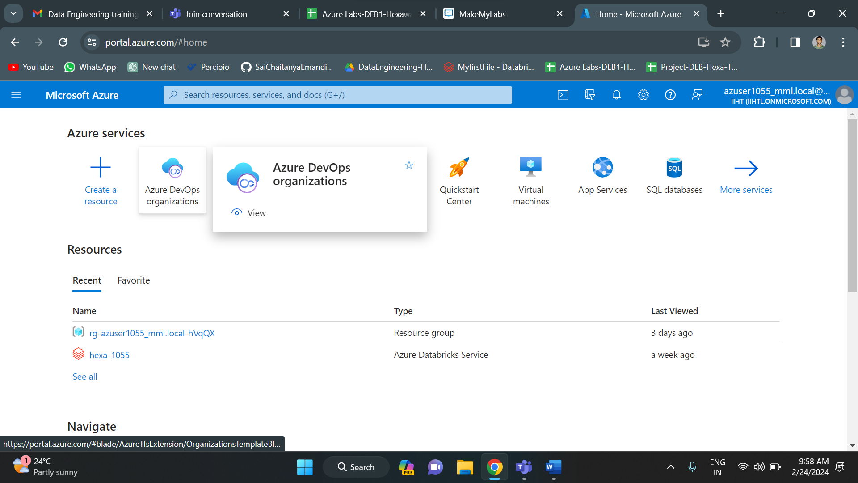

Click on azure devops organization.

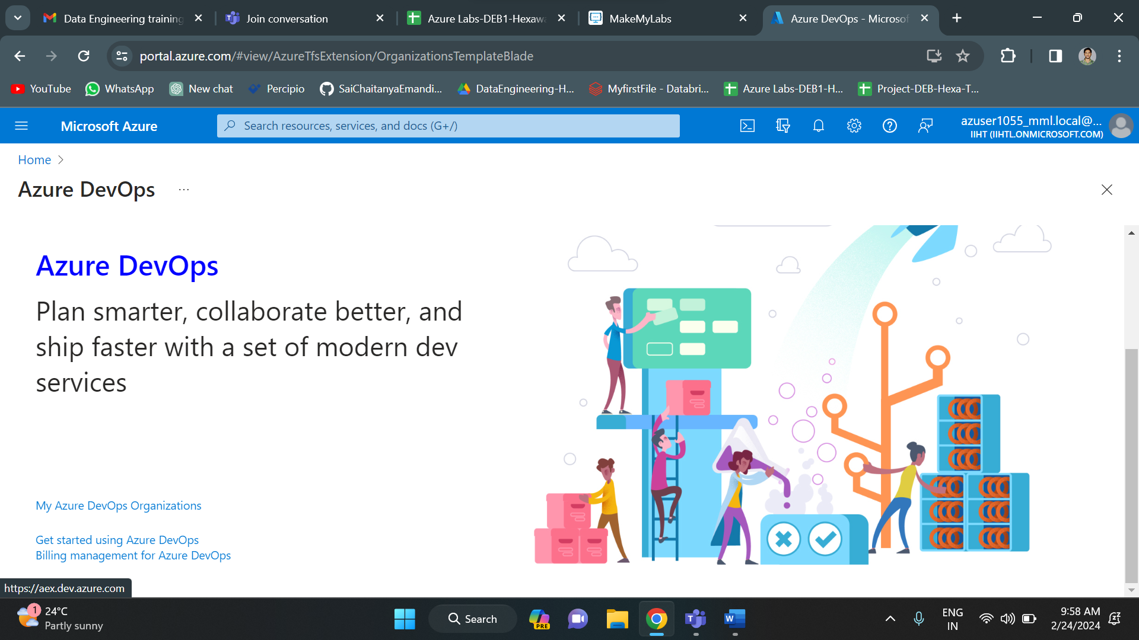

Click on my azure devops organizations below.

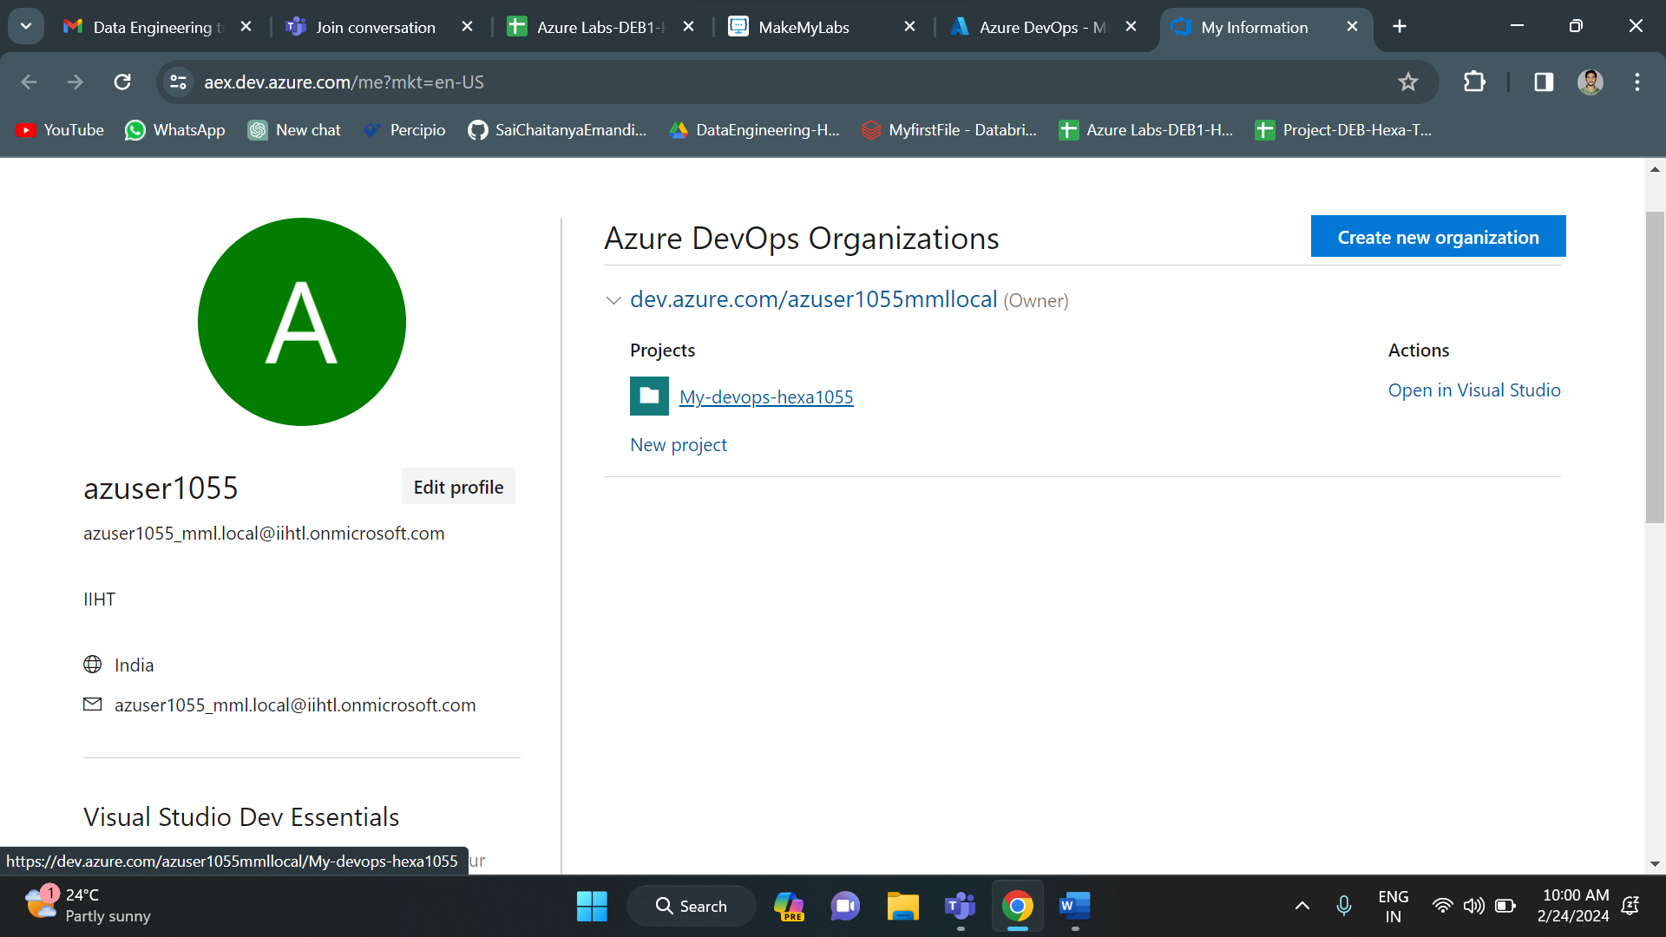

I have already created a new project with “My-devops-hexa1055” as its name. Click on it.

Creating a new epic in azure boards.

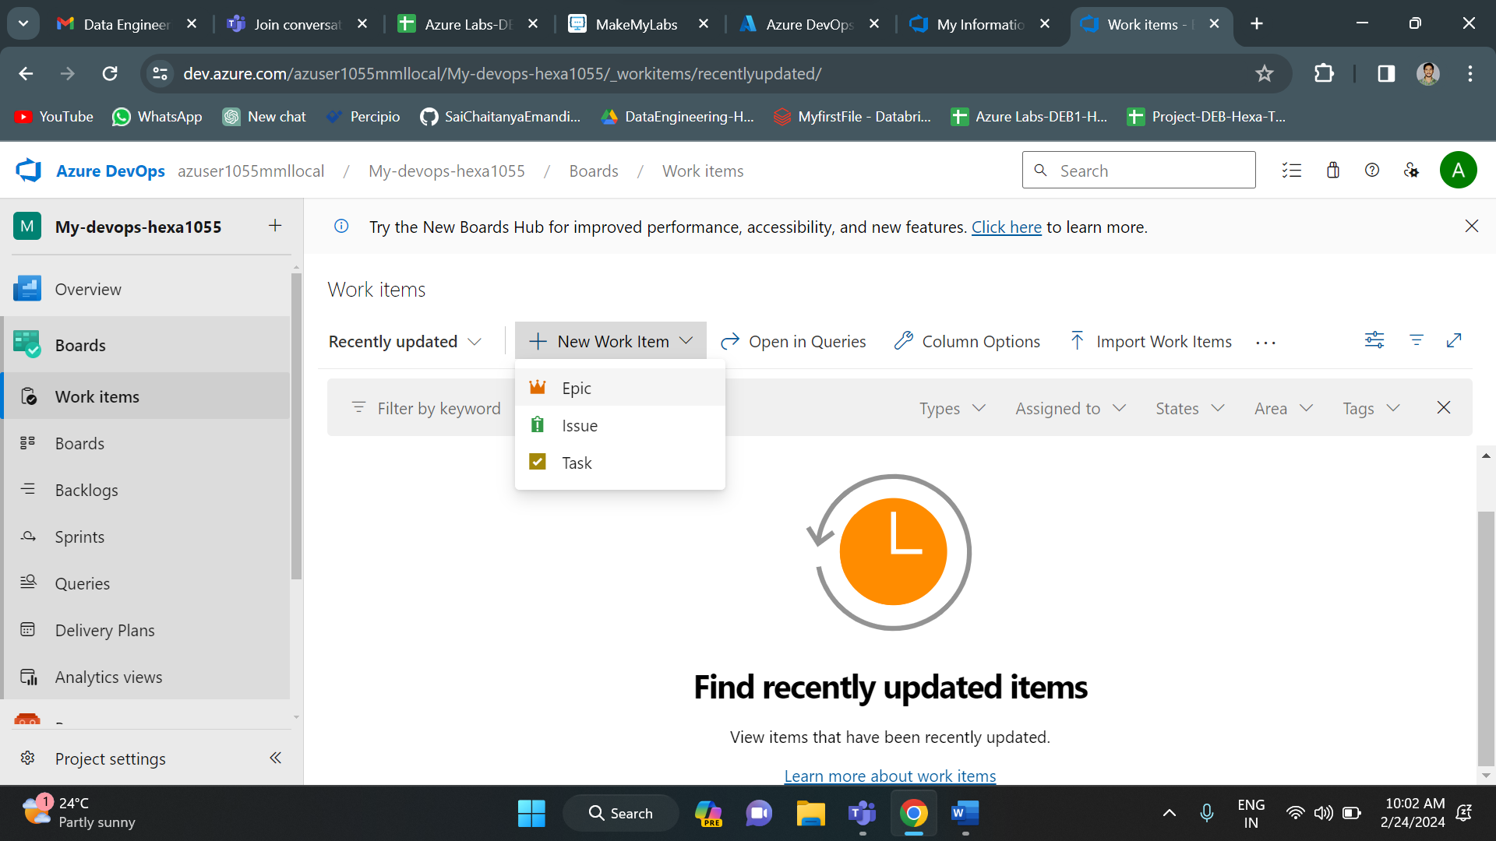

I have a created an epic name Team A.

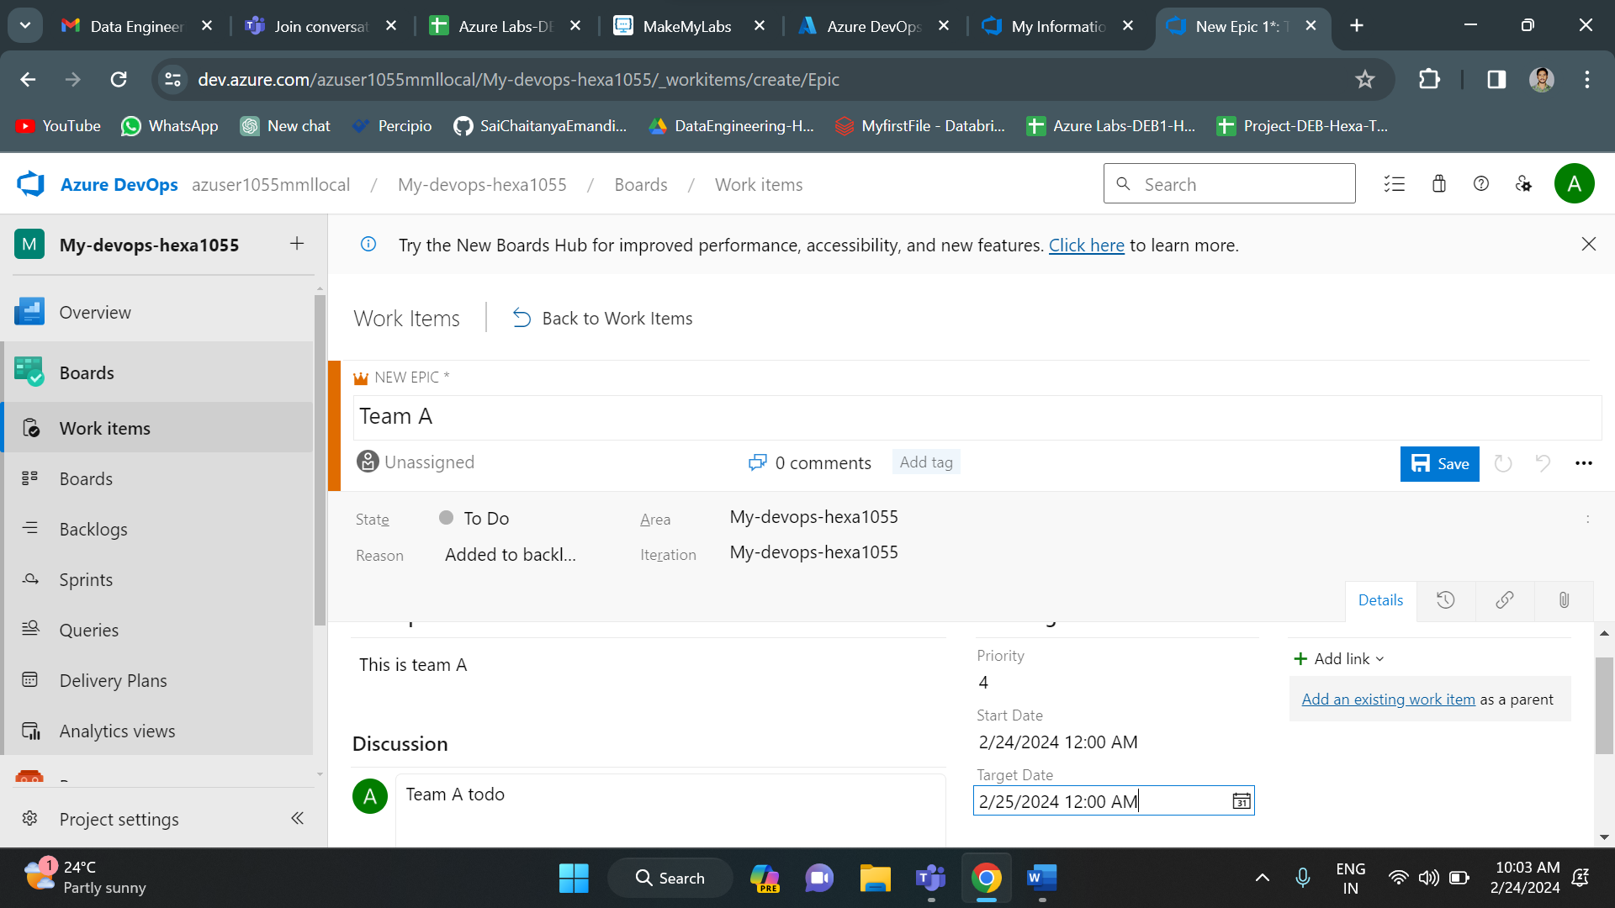

Similarly, I have created another epic with name Team B. And below are the epics in my azure boards.

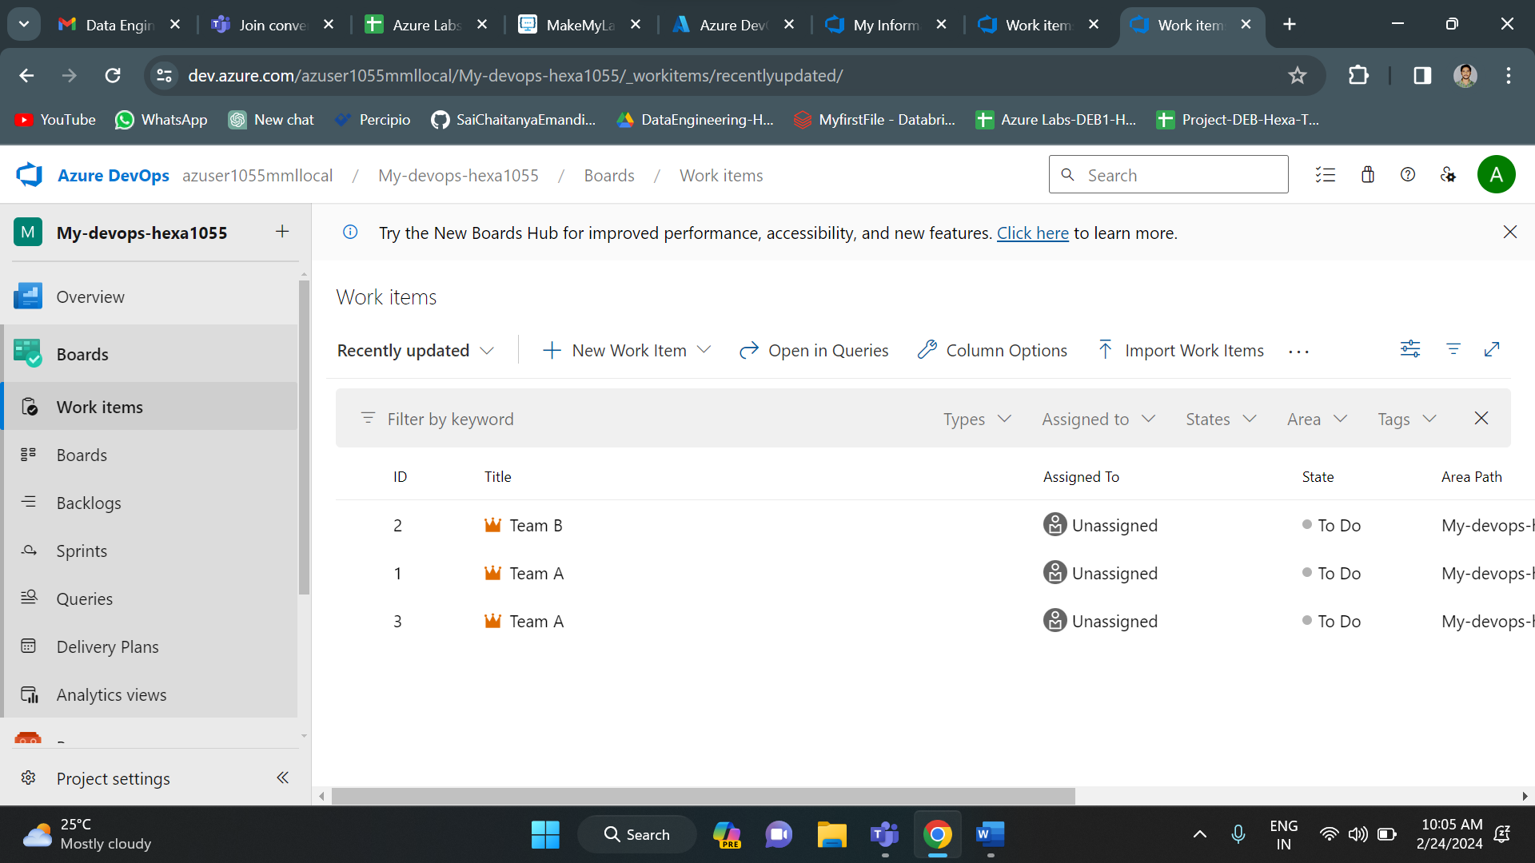

Now we can filter these epics using queries in azure boards. Click on queries and select new query.

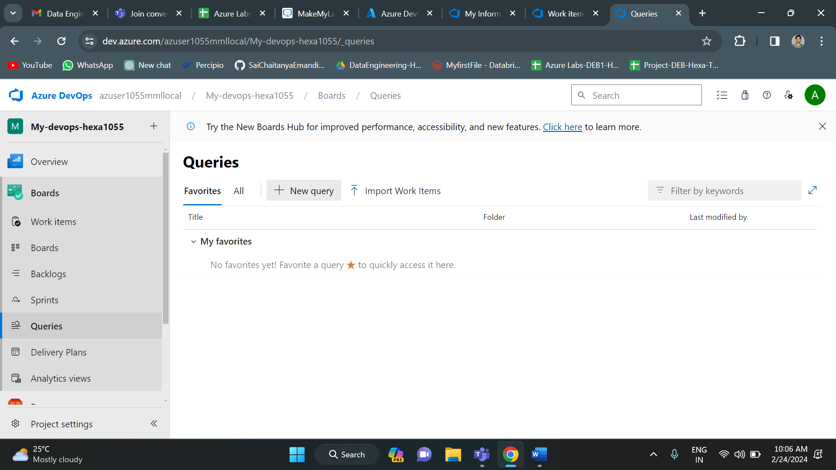

I am trying to filter the epics based on ids. Here I have filter epics whose ids are less than 3. And the output is id 1 an id 2.

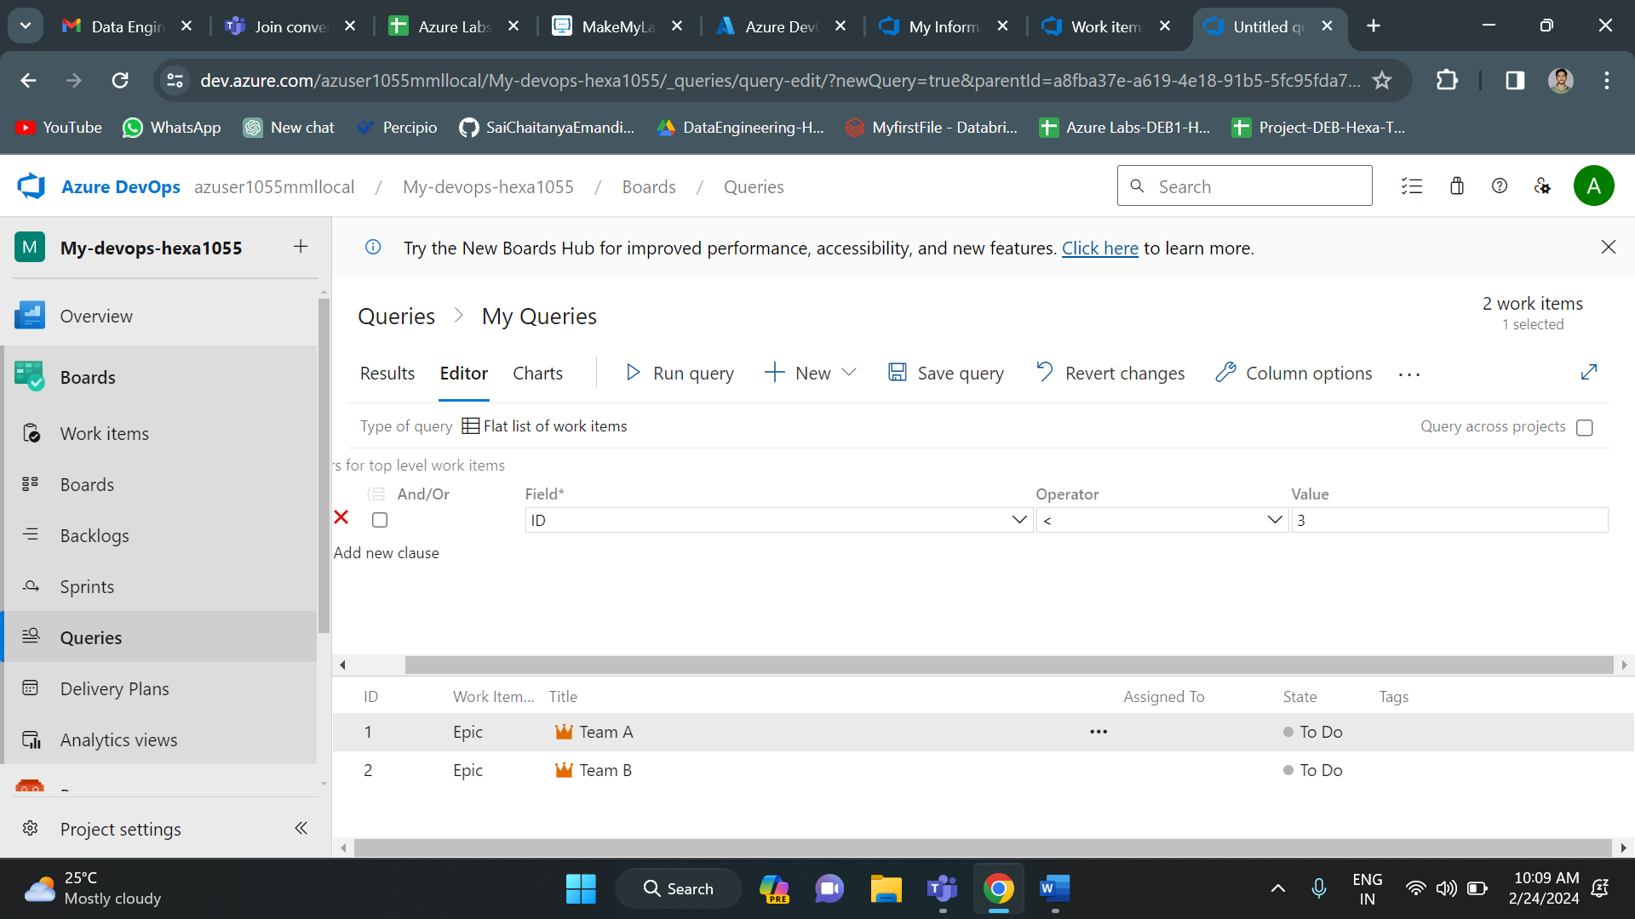

So, in this way you can create epics in azure board and run queries on them to filter the epics.

**Hand written notes:**

